
roots
connecting for us

CS 147 autumn 2025
Community Resilience
Naomi L | Aimen E | Mai H | Angela W

Table of Contents
- Project name & value proposition
- Team member names & roles
- Problem & solution overview
- Needfinding
- POVs & experience prototypes
- Design Evolution
- Final Prototype Implementation
- Reflection & Next Steps

Project Name & Value Proposition

Project Name
roots

Value Proposition
connecting for us

Team Member Names and Roles

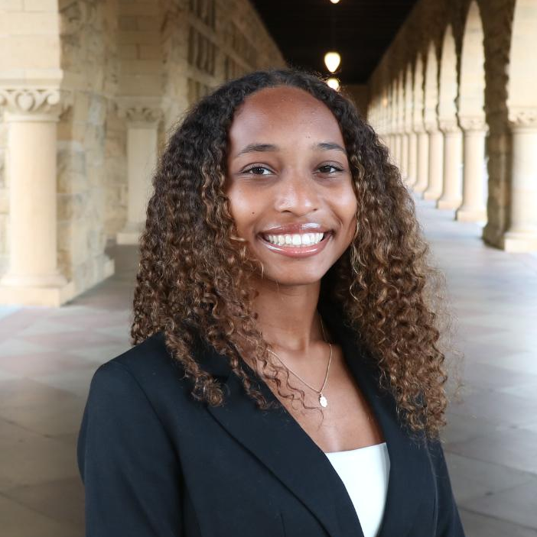

Naomi L. Aimen E.

App Developer App Developer



Mai H. Angela W.

App Developer UI/UX Designer

Problem and Solution Overview
Immigrant parents and children often struggle to connect across cultural and generational gaps. Roots is a mobile application that provides guided prompts, storytelling activities, and shared reflection spaces that make it easy and natural for families to talk, preserve heritage, and strengthen their bond.

Needfinding
Before beginning our needfinding process, we spent time narrowing our domain to something that genuinely resonated with our team. All of the team members were interested in motherhood and its challenges, and we eventually narrowed it down to what makes communication between parents and children feel hard, or meaningful. We ultimately focused on generational connectedness in families, hoping to understand how cultural expectations, communication styles, and everyday routines shape these relationships.

Interviews
For our needfinding phase, we conducted nine interviews across a wide range of immigrant parent–child experiences. Our goal was to intentionally recruit a diverse sample of ages (both parents AND children), cultural backgrounds, and socio-economic statuses to uncover underlying patterns in generational connectedness. We recruited participants through a mix of in-person street outreach at Town & Country and Mountain View, where we invited passersby to talk about their families. To talk to kids below the age of 18, we reached out to parents on NextDoor to see if their kids would be willing to talk to us. Most participants were engaged informally and voluntarily, they were thanked for their time as compensation.

Lucia, 44
- Background: Mexican American, second-generation immigrant, mother of three boys, full-time business owner.
- Key Themes: Prioritizes presence with her kids because her own parents were always working; experiences tension due to cultural differences and authoritative parenting style.

Ananya, 14
- Background: High school student, Indian American who grew up in Singapore before moving to the Bay Area.
- Key Themes: Feels her relationship with her parents mirrors a “manager–worker” dynamic; trusts her friends more due to different expectations of emotional support.

Mohammed, 30s
- Background: Afghan American, co-owner of family business, second-generation immigrant.
- Key Themes: Shifted from a culturally strained relationship with his father to a more collaborative one; carries intergenerational pressure and community-first values.

Emily, 60s
- Background: Mother of a transgender daughter and a son in their 40s; longtime Palo Alto resident and Stanford alum.
- Key Themes: Describes a complex parenting journey shaped by generational shifts, acceptance, and evolving cultural norms.

From these interviews, our team decided to change our domain from generational connectedness in general, to generational connectedness specifically in immigrant families. People we then sought to interview would be immigrant parents and children. This narrower domain felt more relevant to our team. To gather further information we interviewed…

Olivia, 14
- Background: Salvadorian–Taiwanese teenager from Palo Alto.
- Key Themes: Has unusually strong communication with parents; aware of generational cycles and how her mom broke many but still holds some harmful patterns.

Dr. Helen Hsu
- Background: CAPS Outreach Director; clinician with 20+ years of experience, specializing in Asian American and immigrant family mental health.
- Role: Expert interview.
- Key Themes: Immigrant parents desperately want to connect but lack culturally specific tools; communication skills are learnable at any age.

Cathay and Dan
- Background: Parents with 3 kids ages 18+, now living across the U.S. and Europe.
- Key Themes: Offer long-term perspective on raising children across continents and sustaining cross-border relationships.

James, 13
- Background: teen boy from the Bay Area.
- Key Themes: Provides younger-teen perspective on trust, communication, and cultural identity.

Martha, 30s
- Background: Local adult participant.
- Key Themes: Provides insight into family traditions, cultural expectations, and maintaining parent relationships as an adult.

Synthesis
To unpack the interviews we created empathy maps using sticky notes that captured different things our interviewees said, did, thought, and felt.

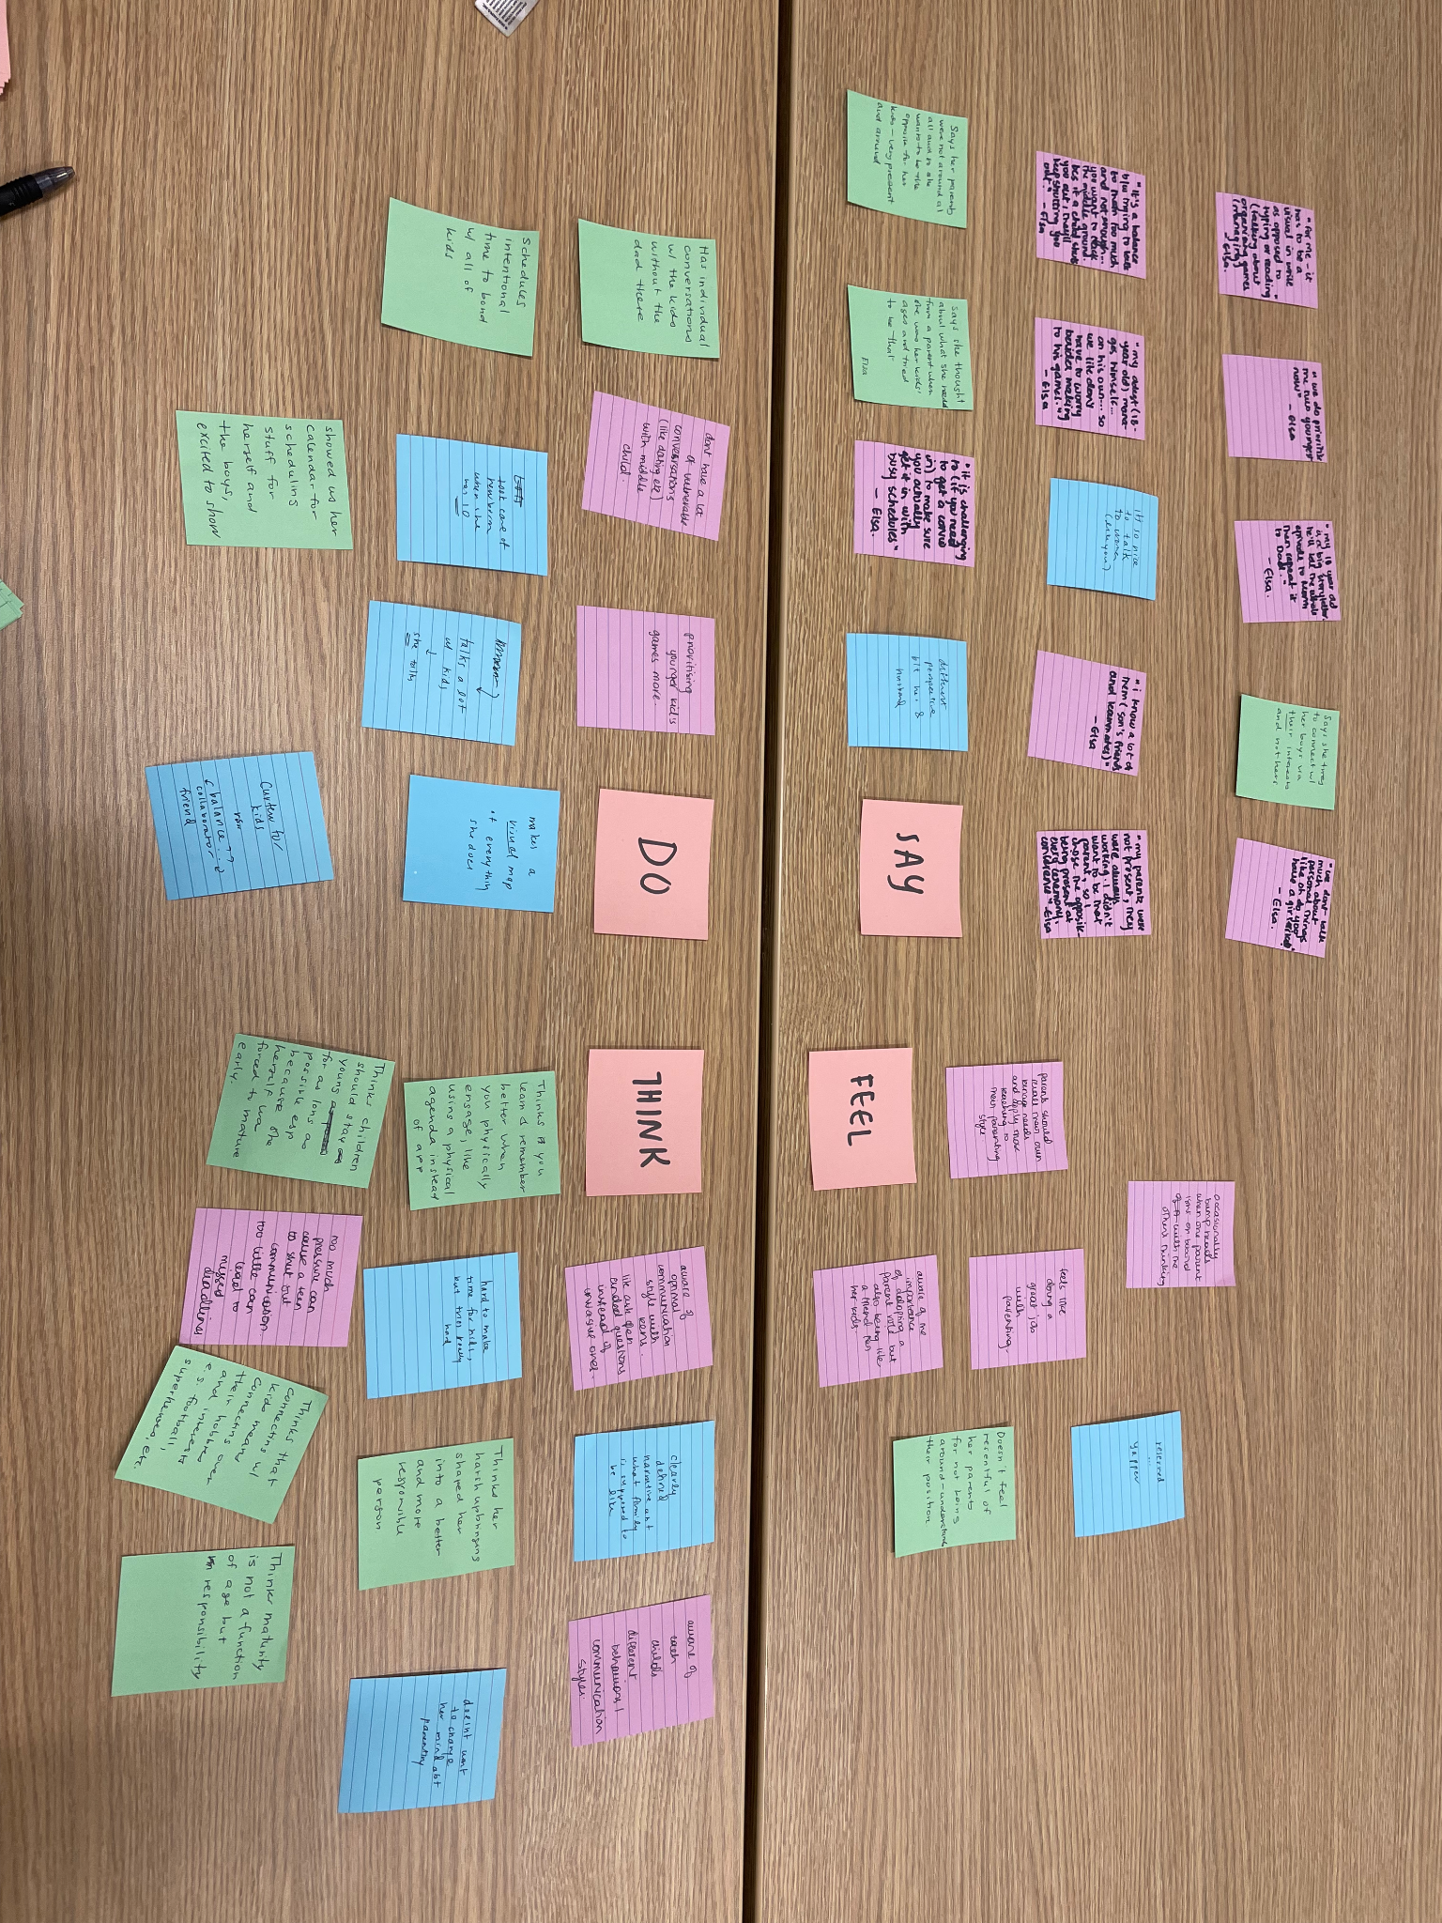
Fig 1: Empathy map for Ananya. Each quadrant represents categories (say, do, think, feel) that break down his thoughts to core emotions, which can help elucidate hidden and unobvious needs. We made empathy maps to explore needs for all our interviewees.

When analysing our empathy maps, we identified some major takeaways that would heavily influence the direction for the rest of our project. Children often expressed a deep desire for closeness but described barriers in doing so such as cultural differences and power dynamics. Parents also expressed a desire to feel closer to their children, but did not know how to approach such conversations, especially with such bus schedules. Both parents and children, while acknowledging having family time for connection, lack 1:1 meaningful moments where real emotional connection can happen.

POVs & Experience Prototypes

We then evaluated the different empathy maps we created for each interview and decided to select the three most engaging interviews to unpack and analyse more fully. We selected three users (Lucia, Mohammed, and Ananya), and generated a point of view (POV) statement for each interview. From each POV, we created 10 How Might We (HMW) statements that would help us in brainstorming solutions to our identified needs. Below are the different POV statements we created along with the HMW statements that arose from them.

Lucia POV
- We met: Lucia, a 44 year old mom of 3 boys, full time business owner and daughter of immigrants from Mexico.
- We were surprised to notice: that even with her packed schedule, she prioritized getting even 10 minute chunks of time with her kids - while these small blocks seem “routine” for other parents, Lucia feels closer and more secure in her relationships with her children.
- We wonder if this means: that to her, parenting means presence rather than elaborate gestures. With the time and financial constraints of working parents, they care about intention and consistency rather than grand emotional or financial gestures.
- It would be game changing if: we stopped designing for family time as a big event and started designing for these small and brief, but meaningful moments of connection.

HMW Statements from Lucia’s POV
- HMW make the in-between moments of everyday life (commutes, meal prep, clean up) into small moments of connection between working parents like Lucia and her children?
- HMW find ways to track these micro-presence moments?
- HMW get kids to be present in conversation with their parents during the mundane moments of their day?

Mohammed POV:
- We met: Mohammed, a 30 year old son of Afghan immigrants and a co-owner of the family business
- We were surprised to notice: the shift from a strained, culturally charged relationship with his father transformed into a more intentional and collaborative one, not in spite of their cultural differences but because of them
- We wonder if this means: that cultural differences don’t just create barriers, but could give rise to deeper connections precisely because the labor of translating across cultures is itself a bonding ritual that strengthens trust and understanding
- It would be game changing if: we created conditions where difficult cross-cultural conversations feel safe, so that cultural differences can become sources of strength rather than weakness

HMW Statements from Mohammed’s POV
- HMW build structured activities to make vulnerability between immigrant parents and children feel less intimidating?
- HMW help parents be more aware of their children’s moods/emotions?
- HMW rebuild connections between parents and children who have grown apart?

Ananya POV:
- We met: Ananya, a 14 year old high school freshman at Palo Alto high school, child of Indian immigrants.
- We were surprised to notice: that even though she said she trusted her family, she relied more on her American friends for support because she had to develop that trust more
- We wonder if this means: her definition of trust depends on the cultural context: her trust for her family means something different than her trust for her friends.
- It would be game changing if: there were opportunities for families to
- express the differences in these big, emotional definitions, so that they can understand each other more fully

HMW Statements from Ananya’s POV
- HMW turn the process of learning how to empathise across cultures into something fun and enjoyable?
- HMW help parents who have to travel a lot for work bond with their kids better?
- HMW use comedy as a medium for bonding between parents and their children?

Top 3 Solutions From Brainstorming
After compiling many HMWs, we narrowed them down to the top three, highest quality ones. For each of these statements, we used a FigJamboard to brainstorm more than 10 potential solutions that would address each HMW statement. We used a Heat Map technique to select both our top 3 HMW statements and our top 3 solutions. Each person started with an unlimited number of votes (stickers), then everyone got 3 final votes on absolute favorites.

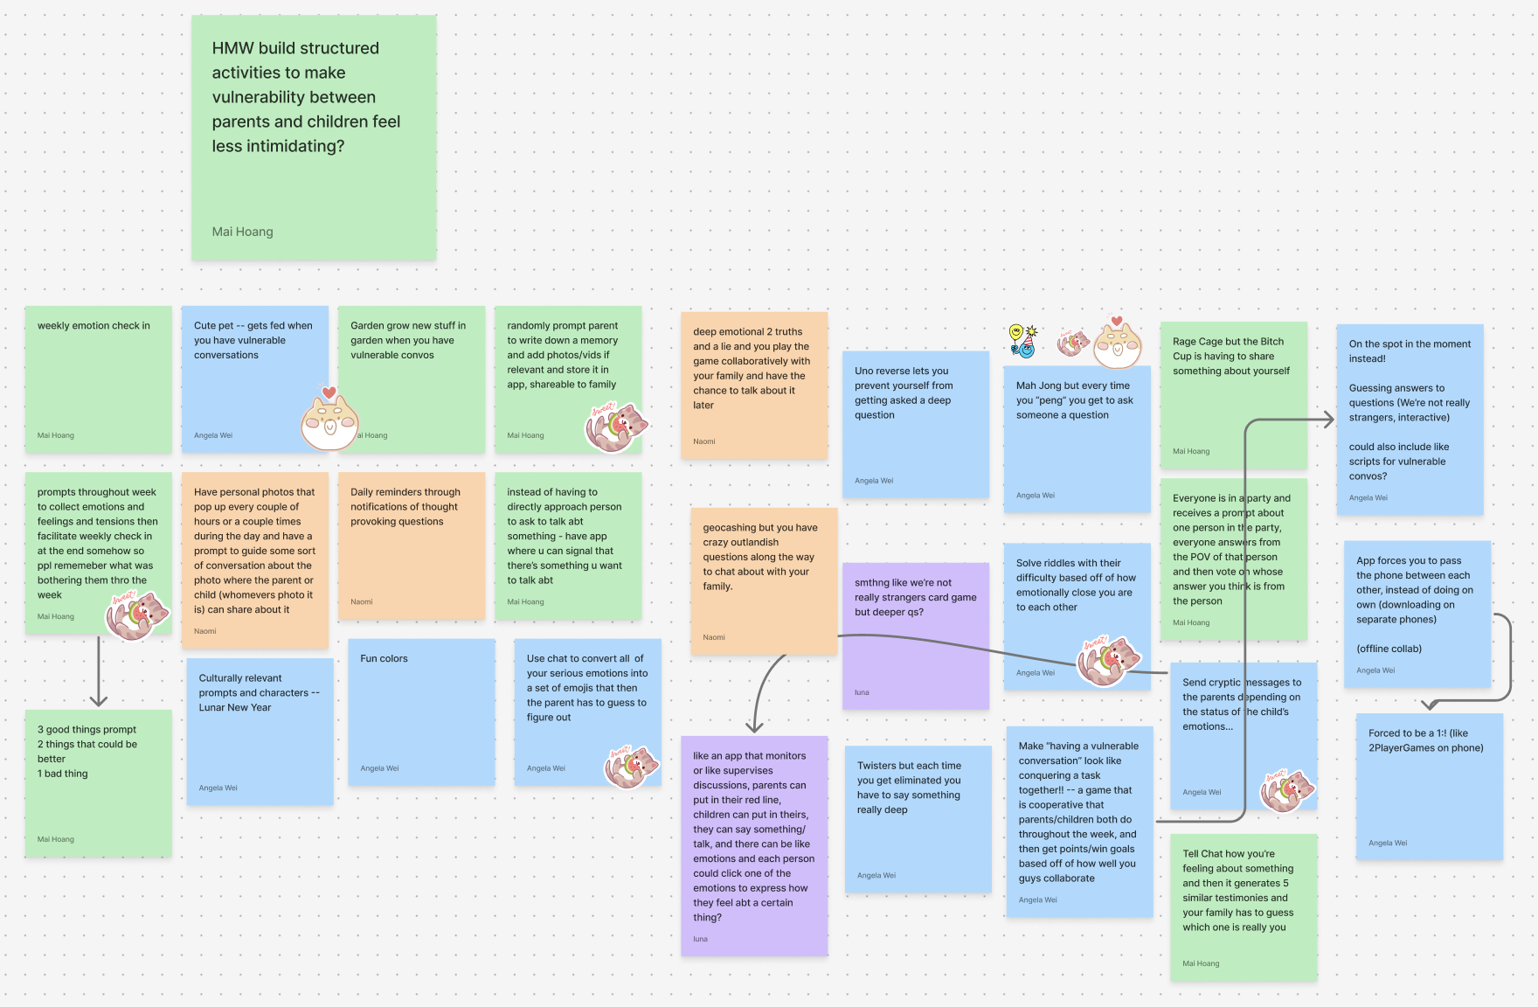
Fig 2: Our Heat Map process of brainstorming and shortlisting solutions

Top 3 Solutions:
- Gamify learning - users advance through short empathy and communication-building lessons using CHIPAO. Points, streaks, and badges are awarded for completing lessons.
- Random reflection pings: prompts arrive randomly in the day asking parents/children to reflect on a moment/conflict or consider the other person’s view. Each takes 3-5 minutes.
- Build up to vulnerability through a co-op quest: parent and child tackle weekly mini-games & challenges together, earn points for collaboration, and unlock goals by completing tiny actions.

Experience Prototypes
To test these solutions, we carefully crafted 3 experience prototypes to ensure key underlying assumptions that the solutions were based off of were true.

Experience Prototype: Gamify Learning

Our first solution was an app where users advanced through short empathy and communication building lessons.

Key Assumption being tested: Parents find that online resources are a worthwhile way to learn about communication skills.

We used a 5-minute Youtube skit from CHIPAO that teaches culturally specific communication skills. We tested this on 2 Chinese parents, asking them to answer a brief survey about their experience with learning about communication skills before the video. Then we showed them the video and asked them afterwards what they learned from it, how engaging it felt/whether they would do it by themselves.

Parents really enjoyed this prototype experience and were quite receptive to the videos. Their only concern was applying these skills they learned in the moment.

From this prototype experience we learned that learning these skills in a business setting helps people communicate with their families better. This implied that moving forward, we had to keep in mind that we were designing for families for whom therapy is not necessarily a conceptual framework. So we had to design an app that doesn't just provide information, but helps one implement those skills too.

Experience Prototype: Random Reflection Pings

This solution was providing prompts randomly in the day asking parents/children to reflect on a moment or consider the other person’s view.

Key Assumption: People who opt in to a reflection app already have above-average willingness to reflect, and when given brief, guided prompts, this reflection increases relational awareness (empathy/perspective-taking) rather than reinforcing self-bias.

For this experience prototype, we texted people self-reflection prompts about their relationships with others 2-3 throughout the day. This prototype was tested on 5 people (4 adult children and 1 immigrant parent). We had participants take a survey before and after the experience asking how much they care about introspection, how willing they are to change their behaviour for others, and how engaging in self reflection has helped them.

Users really engaged with this prototype with deep, thoughtful answers. Specific prompts helped people with reflecting. Users also repeated feeling more empathetic towards the other after responding. However, some users focused too much on giving a polished answer and thus took a while answering the prompts. People with lower tech usage also gave less comprehensive answers.

From this prototype testing we learned that immigrant parents, while open to reflection, aren’t as involved with Western psychology practices like journaling and therapy. Moving forward, this meant that we had to make it seem like less of a therapy/journalling practice and more of a task/challenge, so at most 1 prompt a day would be a good and easy-to-do task. We also realised that it would be a good idea to have a set time window during which the user had to answer instead of leaving it on them to answer whenever.

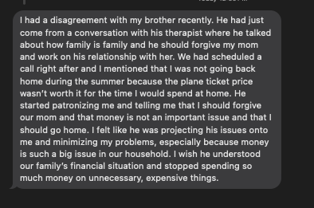


Fig 3: texts our participants sent us as their responses for this prototype

Experience Prototype: Gamified Vulnerability

For this solution, we decided to build up to vulnerability through a co-op quest: parents and children tackling weekly mini-games and challenges together through collaboration.

Key Assumption: Games help parents and children open up and build deeper connections because they’re casual and lower the stakes.

For this prototype, we had users have a live phone call with their parents and ask each other random questions, if they chose not to answer, they had to do cute silly dares. We tested this prototype on an Indian international student and his mom. We asked the users how easy it was for them to open up to each other on a scale of 1-10 both before and after the prototype testing.

Users reported liking the questions and learning much about the other person, they mentioned questions like these made opening up easier as they were not used to asking each other such questions. Users also enjoyed answering the questions, both parents and children were laughing and enjoying themselves.

From this we learned that play/games lower the barrier to vulnerability: it makes it genuinely enjoyable for both children and parents, and provides a low stakes environment for people to leave their comfort zone.

Going forward, we realised it would be better to mix up questions a bit e.g. alternating between lighter and deeper prompts.

Design Evolution
Final Solution

Our finalized solution is an amalgamation of the valuable insights from our needfinding process, interviewees, and prototype experience evaluations. Through our first-round interviews during our needfinding process, we gained valuable insight as to how the immigrant parenting experience and the experience of being the child of an immigrant is an entirely different reality than that of parents and children that have the same cultural background. Additionally, during our Low-fidelity prototype testing, we found that the parental needs of approaching inter-cultural connection within families differ substantially from the needs of their children. Through our testing feedback we also observed how a dual parent-child user design may hinder the effectiveness of how readily parents respond to and integrate our resource into their daily lives.

After a thorough evaluation of our gathered feedback and observations, we decided to center our final solution on providing a resource for immigrant parents to learn and develop culturally relevant communication skills with their children and put such learning into practice. Our enhanced focus on the parent’s perspective consequently solidified our design to focus solely on immigrant parents as the primary user.

Tasks
Task 1 ~ Simple: Learn an empathy skill
This task is fundamental to the purpose of roots and is something that all users are meant to engage in upon first encountering the app. This task provides the opportunity for users to learn core communication skills from research based resources such as Stanford’s CHIPAO organization. The learning flow allows users to learn in different modalities such as readings, videos, and personal reflection.
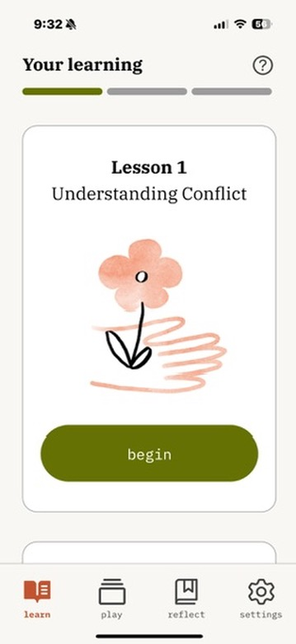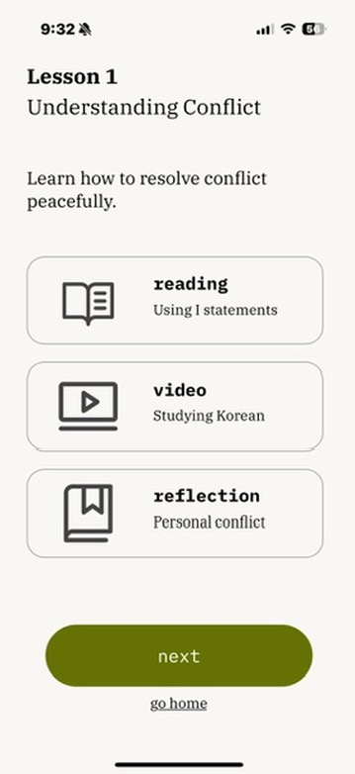
Users can choose to begin one of multiple lesson modules that are sequentially unlocked upon previous lesson completion. Once a lesson has been unlocked, a user can always return to the lesson and go through it at any time.
Task 2 ~ Moderate: Play a game
Once a lesson has been completed, the goal is for the user to put their learning into practice. This task is meant to be completed between the user and their child, providing an opportunity for the user to implement their recently learned communications skills in conversations and open up a less pressured way for children to have meaningful and vulnerable conversations with their parents. Additionally, at the end of the game flow, users have the opportunity to document the moment by taking a picture with their child and writing a message that will be saved in their scrapbook.
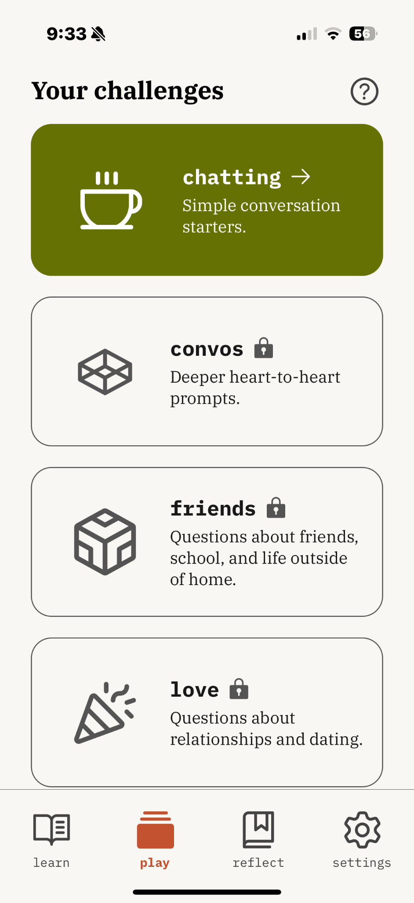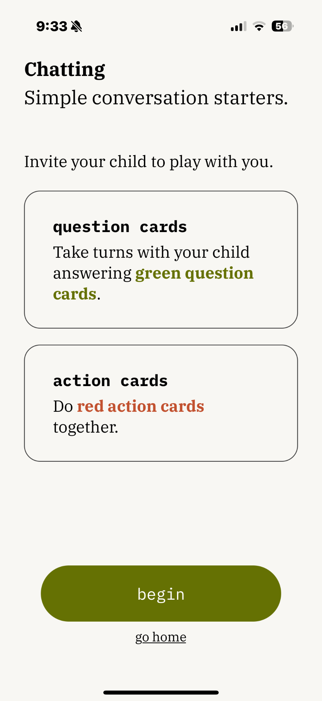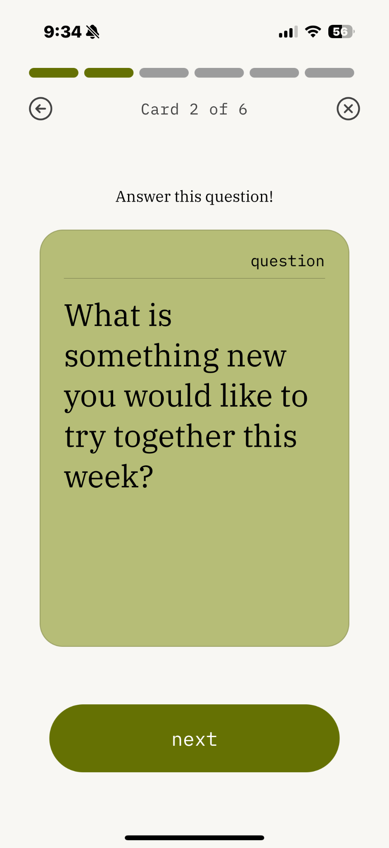
Users can choose to play one of multiple games that are sequentially unlocked upon previous game completion.

Task 3 ~ Complex: Reflect on a memory
The complex task is to reflect on a memory through the scrapbook feature. Here, users can view the memories that they have made with their children through images and past journal entries or reflect on their lesson reflections from each lesson. This feature provides an incentive for users to document personal reflections from lessons and memories made between them and their children. This is an added layer of support to encourage users to put their learning into action, track their growth over time, and take the time to reflect on their encounters with their children.
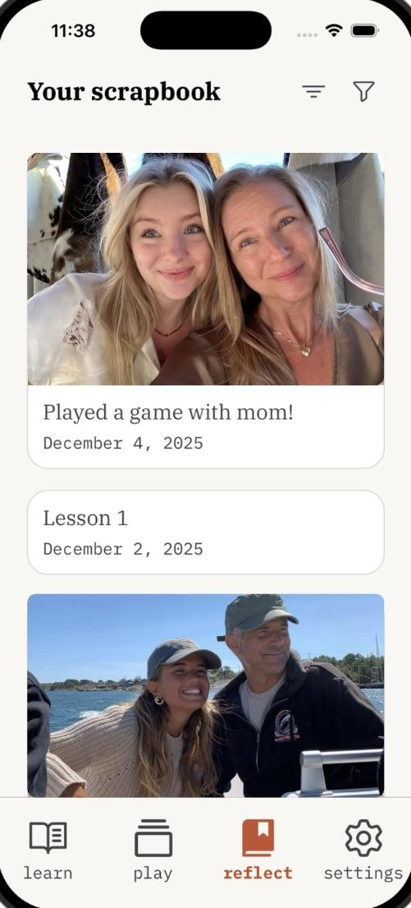
Users can sort scrapbook entries by date and filter them by game reflection or lesson reflection. Additionally, users can edit, share, and delete their entries at any time.

Design Evolution Visualizations and Rationale
During the initial sketching stage, our team brainstormed a variety of design directions, including mobile applications, wearables, and game options. After analyzing the usability and feasibility of each medium, we decided to proceed with the mobile application, since mobile applications are far more accessible and easy to use. Given that our audience are older, immigrant parents who may have limited experience with technology and limited understanding of English, we felt that building a mobile application would suit their needs better.
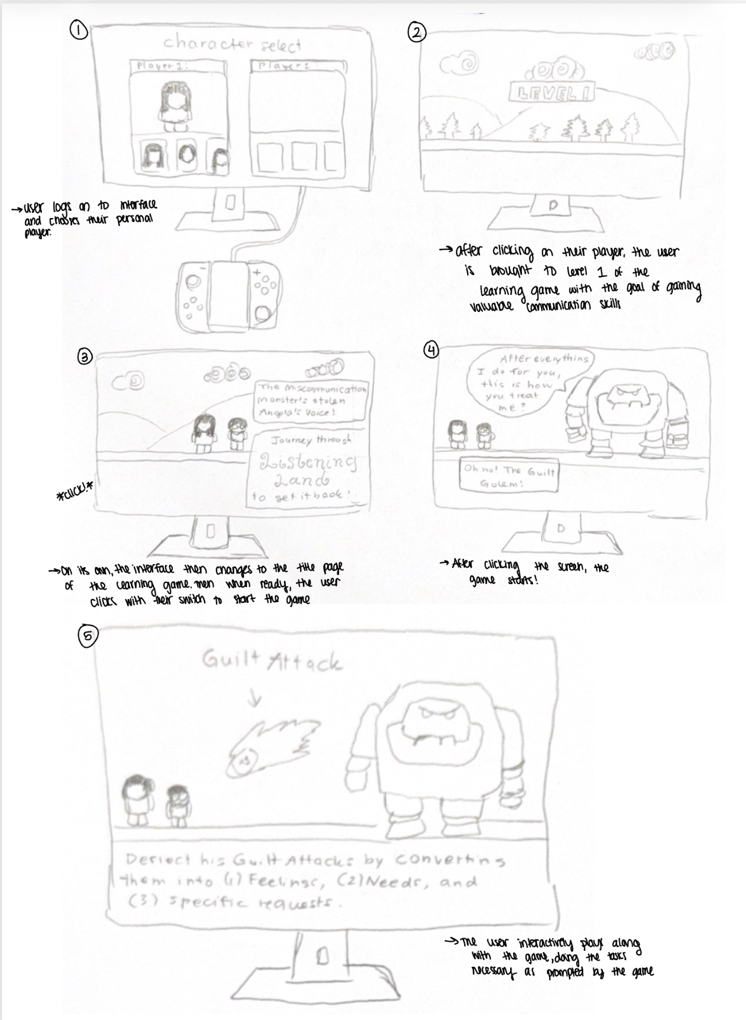
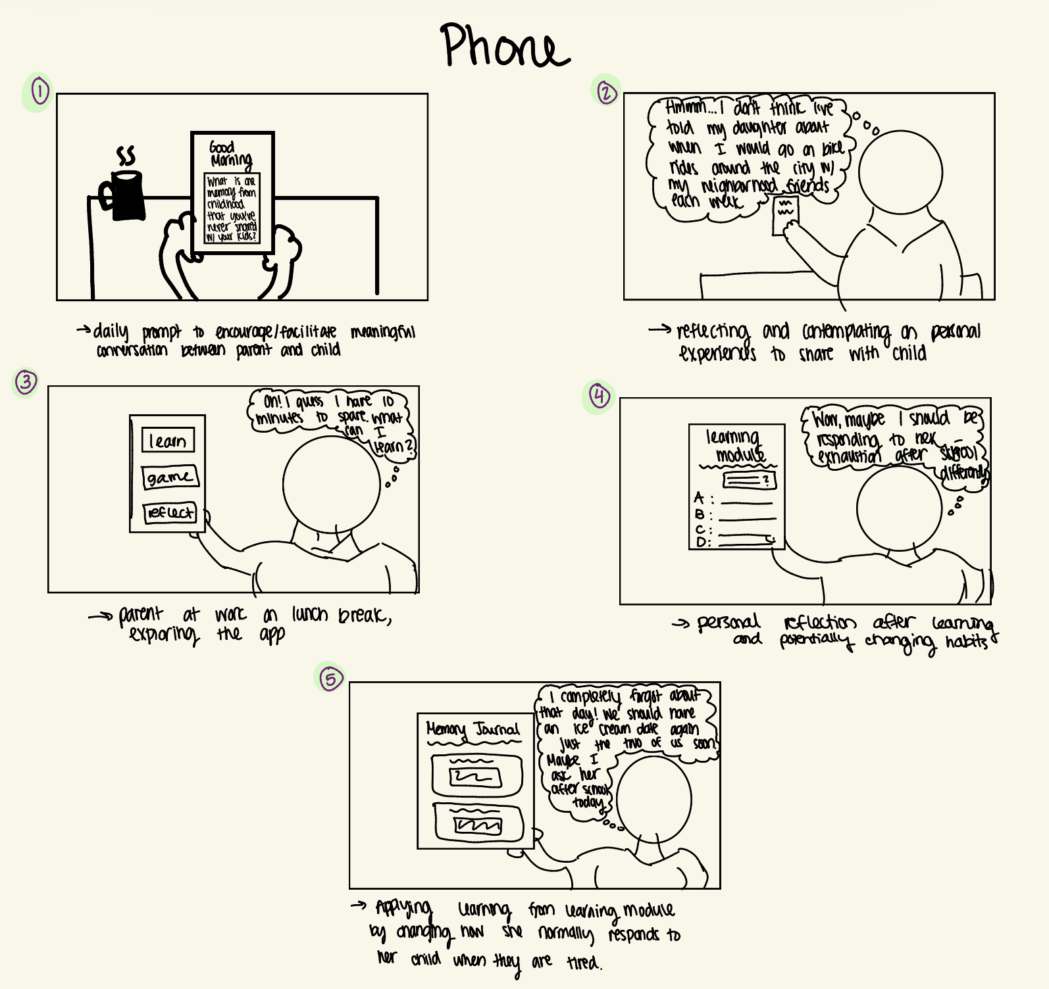
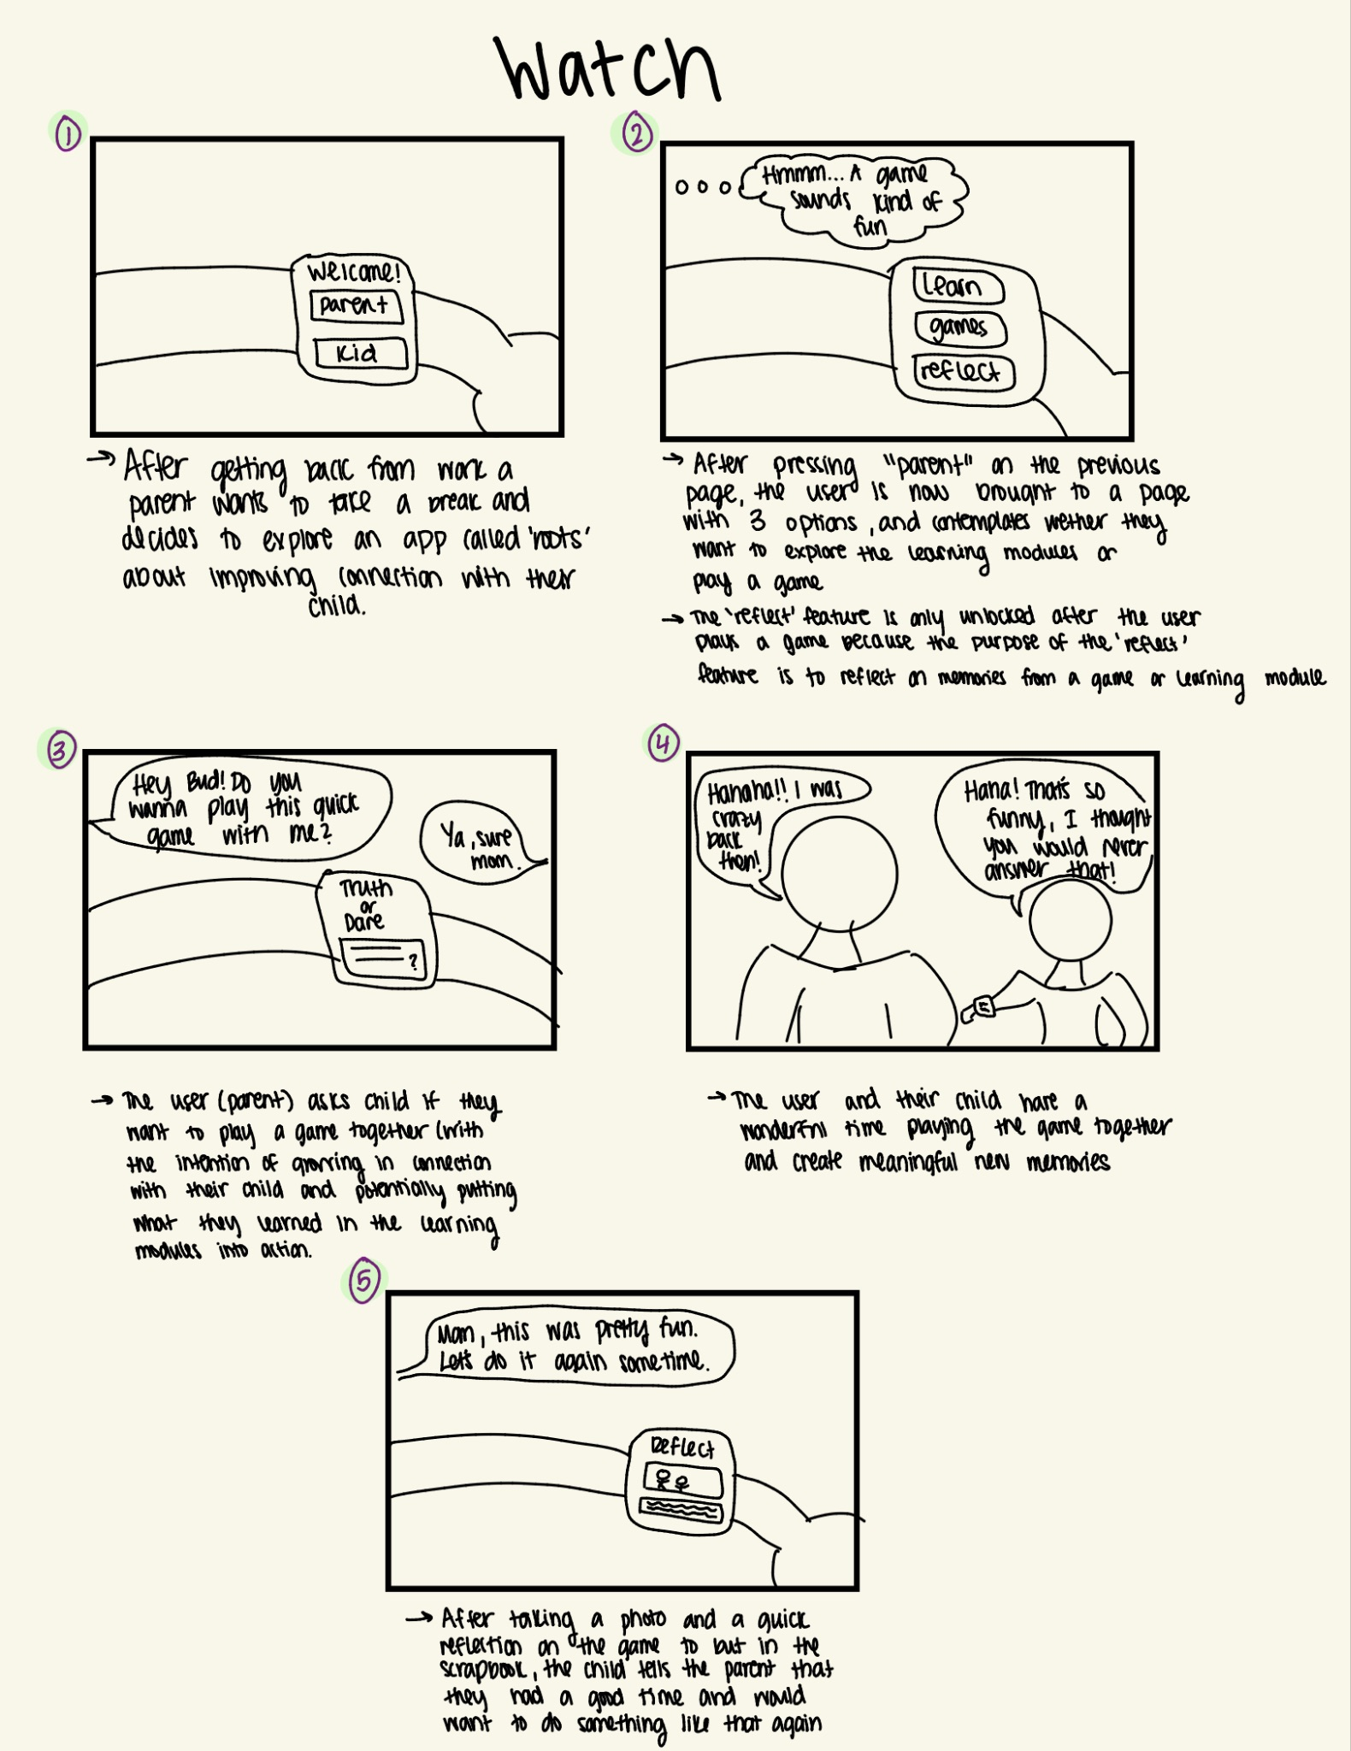

Figure X: Initial sketches of mobile, watch, and Nintendo Switch applications for roots.

Lo-Fi Prototype and Evaluation
After selecting a mobile application as our realization, we sketched out task flows for our three tasks. This iteration consisted of hand-drawn sketches on paper that explored potential flows through onboarding, lesson content and structure, game content and structure, and scrapbooking. These sketches helped map out the narrative sequence: lesson -> game -> scrapbook, while leaving room to experiment with tone and positioning of key UI elements.

Initially, we designed the lo-fi prototype to cater to both immigrant parents and their children. As such, user testing was conducted on four participants from both these demographics. We tested on two older immigrant parents and two young high school students with immigrant parents. Each participant was asked to navigate through our key task flows on the app and think out loud as they went. We gathered qualitative data from their comments and we also measured quantitative measures such as the number of misclicks. We also asked them to rate how intuitive our app felt on a scale of 1-10 and how likely they would be to use each part of the app on a scale of 1-10.
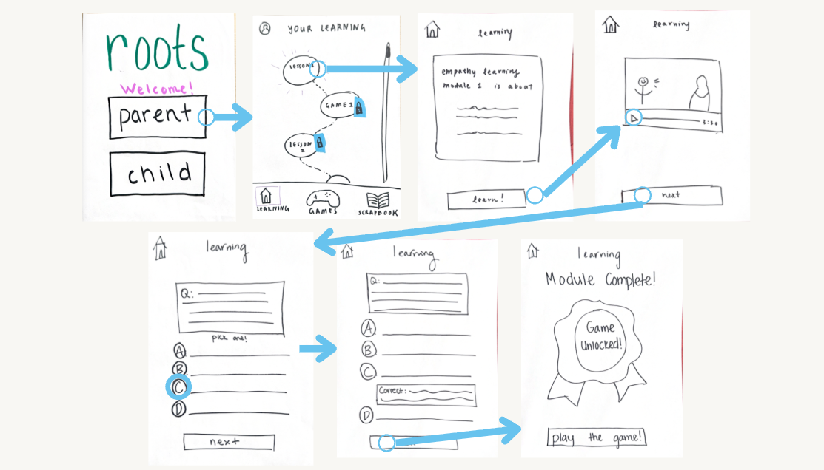
Figure X: Lo-fi prototype flow for our first simple task (learn an empathy skill).

Across all participants, the interface was described as intuitive, and everyone was able to complete all assigned tasks, although with varying times. Nearly all users enjoyed the “bite-sized” learning modules and expressed eagerness to explore more of the app.

However, clear differences emerged between older and younger users.

Younger Participants:
Younger participants quickly understood the interface and made 0 misclicks while completing the tasks. They rated the prototype an 8.5/10 for intuitiveness and 6/10 for likelihood of use. They felt neutral about the games unless initiated by parents. Many felt that lessons and games should begin with lower vulnerability prompts and progress up. A key insight was that younger users would only play the game “if my parents brought it to me.”

Older participants:
Older participants struggled more initially, making 7 total misclicks when navigating through the tasks and rating intuitiveness lower (7/10) but expressing higher likelihood of use once comfortable (8/10). They were confused by:
- Bottom-up home layout (expected top-down hierarchy)
- Scrolling gestures (especially in the scrapbook)
- Which module to start first
- The purpose of reflection (“Am I supposed to reflect on the game? On the lesson?)
They also expressed that they did not want children to download the app, citing concerns about screen time. All recorded misclicks occurred within this group, reinforcing the need to design intentionally for older immigrant parents—our primary user base—using literal labels, clear visual cues, and explicit instruction.

Implications and Changes
This round of testing produced most of the major design shifts in the following iteration.

The most significant change we made was to shift the app’s focus entirely to immigrant parents, and remove the flow for children. This addressed the older participants’ concerns about screen time, the younger participants’ hesitancy to use the app, and overall aligned better with our design values to strengthen face-to-face connections between parent and children rather than replacing them with in-app interaction.

We also made several UI changes in response to the older users’ confusion:
- Added explanatory text beneath all buttons
- Increased text size on the home screen and throughout lessons
- Added a scrollbar and stronger visual cues to show scrollability
- Highlighted the currently selected module to guide task order
- Added explanatory text to the game, scrapbook, and lessons
- Replaced swipe gestures with labeled buttons (e.g., “Next Page”) to reduce hidden interactions
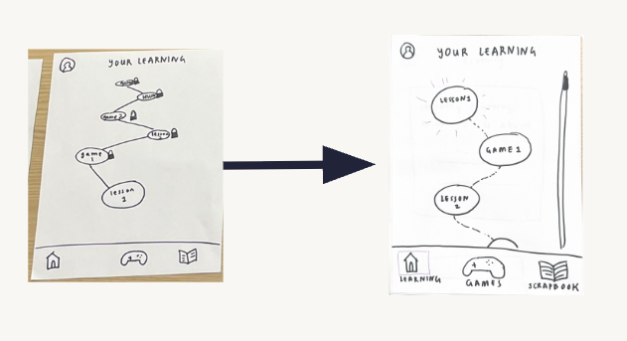
- Introduced sticky-note “locks” to indicate modules that cannot yet be accessed

Figure X: Changing the bottom-up hierarchy for lessons to a top-down hierarchy.

Medium-Fi Prototype and Evaluation
The medium-fi prototype translated the feedback from the low-fidelity prototype into more structured screens with the same tasks.

Some key design decisions were made at this stage, including:
- Fontfaces used (IBM Plex Serif and IBM Plex Mono)
- Color palette that balanced warm and legibility
- App vibe: playful but simple

To evaluate our medium-fi prototype, our classmates conducted a heuristic evaluation during studio. We received 53 total violations, 19 of which were severity 3-4 issues. The lower severity heuristic violations led us to make some generalized changes such as making wording consistent across pages and adding confirmation screens to clearly communicate the state of the application to the user.

For the 19 severity 3–4 violations, we made nine substantial revisions and deliberately chose not to act on the remainder.

Simple Task / Violation #1 / H11 / Severity: 3
- Issue: No captions for videos, which may be difficult for speakers where English isn't their first language.
- Revision: Added captions on videos.
- Rationale: Accessibility for all is a key value for us, and being deaf or hard of hearing should never restrict the user’s experience.
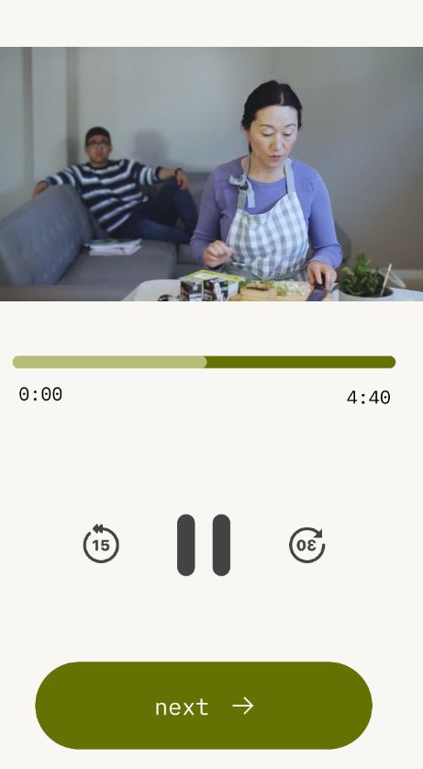
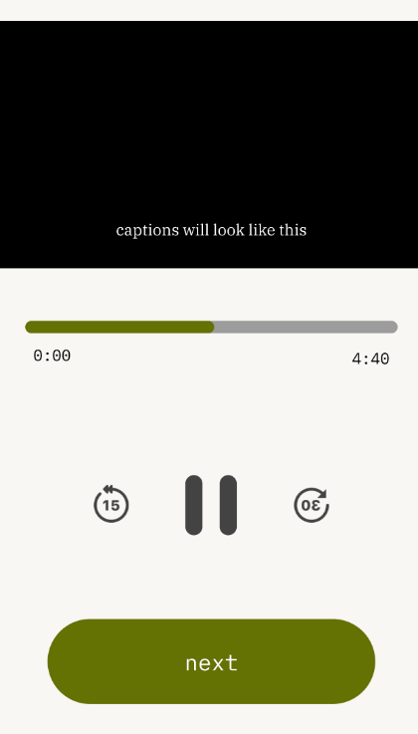

Figure X: Adding captions to our medium-fi prototype.

Simple Task / Violation #2 / H3 / Severity: 3
- Issue: Once a user hits “Finish,” there’s no way to go back to edit their reflection or even look at their old reflection.
- Revision: Added edit and delete button and option to see lesson reflection in scrapbook
- Rationale: User freedom is crucial and lesson reflection is a core aspect of app intent

Simple Task / Violation #3 / H4 / Severity: 3
- Issue: Locked Lesson 3 with no explanation: Lesson 3 button appears on the home page but is completely non-functional. Users see it as an available option but cannot interact with it, with no clear explanation of why it's inaccessible or what steps to take to unlock it.
- Revision: Added pop-up modal with information about locked lesson.
- Rationale: Minimize user confusion.

Simple Task / Violation #4 / H6 / Severity: 3
- Issue: No indication, especially for older users, that the scroll indicator on the right of the "Learn" tab means that there are multiple lessons if you scroll down.
- Revision: Implemented clearer scroll feature. Added tap feature to quickly reach the lesson.
- Rationale: Clear design to enable users to use all features of the app.

Simple Task / Violation #5 / H7 / Severity: 3
- Issue: When users complete a task, they must scroll down to the next task available, which may take a long time if they have completed many lessons on the app.
- Revision: Implemented clearer scroll feature. Added tap feature to quickly reach the lesson.
- Rationale: Clear design to enable users to use all features of the app.

Simple Task / Violation #6 / H7 / Severity: 3
- Issue: No visible confirmation after tapping “Finish” that one of the lessons is done and now we are transitioning to a game/another tab.
- Revision: Added popup to view reflection in scrapbook
- Rationale: Grant users confirmation about completed actions

Moderate Task / Violation #7 / H11 / Severity: 3
- Issue: Too much text...not readable. It would be nice to have a speaker icon to indicate (text to speech) capabilities that read out the content.
- Revision: Added voice feature that pops up.
- Rationale: Eyesight, age, or other needs should never hinder users from app usage.

Moderate Task / Violation #8 / H2 / Severity: 3
- Issue: "Take turns answering cards" -- take turns with who?
- Revision: Changed wording of text
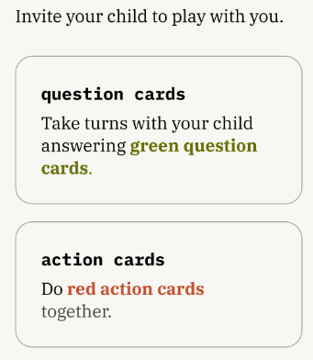
- Rationale: Minimize user confusion
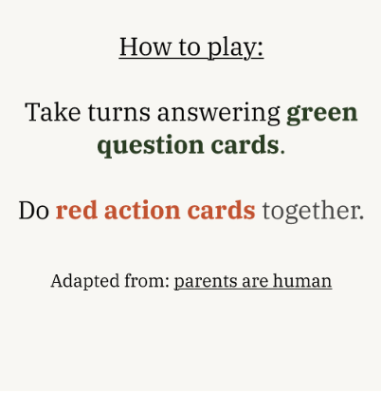

Figure X: Changed text to explicitly say play with child.

Moderate Task / Violation #9 / H3 / Severity: 3
- Issue: No clear way to save progress mid-game, if someone wants to take a break or skip the game, the option isn't allowed.
- Revision: Added “Save & Exit Game” feature
- Rationale: User freedom is crucial.

Complex Task / Violation #10 / H3 / Severity: 3
- Issue: No clear way to skip scrapbook part of app, if users maybe don't want to take a picture or save the memory.
- Revision: Added option for user to skip adding memory to scrapbook and navigate “home” instead
- Rationale: User freedom is crucial.

Complex Task / Violation #11 / H3 / Severity: 3
- Issue: Once users submit and save a memory to the scrapbook, there is no way to edit or delete it. Users are locked into their submission even if they made a typo, want to update a caption, or accidentally saved the wrong memory. There is no undo, no delete option, and no escape from the submitted box option.
- Revision: Added edit & delete options for memories submitted to the scrapbook.
- Rationale: User freedom is crucial.

We chose not to incorporate the rest of the feedback. This selectivity reflects both scope constraints and intentional design decisions about the product’s audience and purpose. In some cases, evaluators flagged the language as assuming a parent–child relationship; however, this framing is deliberate, as roots is explicitly designed for caregivers and their children. Other comments suggested that terminology such as “unlock” or “play challenges” might be inaccessible to immigrant parents, but we ultimately disagreed based on our earlier user research, where parents were familiar with and comfortable using these terms in app and game contexts. Finally, a few violations claimed that the prototype failed to support multilingual accessibility because the evaluators did not see language switching in the screens they reviewed; in reality, the prototype does support multiple languages, as documented in the README.
Values in Design
Identified Values
From the earliest stages of designing Roots, we grounded the project in three core values: education, cultural sensitivity, and connection. These values shaped not only the overall concept of the app but also specific interaction patterns, visual elements, and content structures throughout the prototype.

Education
The first value, education, reflects the belief that anyone can grow empathy and effective communication skills if given opportunities to learn and apply them. This value is embedded directly into the structure of the app, which guides users through a sequenced flow of learning, practicing, and reflecting. Lesson modules are intentionally short and approachable to reduce cognitive burden and support “bite-sized” learning. Each lesson is paired with a corresponding game or challenge designed to help users practice the communication skill in a low-stakes, interactive format. Reflection prompts further reinforce learning by encouraging users to articulate what they understood, how they felt, and how they might apply the skill in real-life interactions. The educational value is therefore instantiated not just through explicit lesson content but also through scaffolded opportunities for application and reinforcement.

Cultural Sensitivity
Our second value, cultural sensitivity, shaped both surface-level features and deeper design decisions. Because roots is designed for immigrant families, we aimed to honor diverse cultural norms, communication styles, languages, and family structures without stereotyping or imposing a single “correct” way to express emotion. This value informed our choice to support multilingual onboarding and lesson content through the i18n system, allowing users to choose the language they feel most comfortable learning in. It also shaped the tone of lesson text, which avoids prescriptive or culturally narrow language and instead frames concepts like empathy or active listening as adaptable practices. Visual elements such as warm color palettes, relatable illustrations, and non-Western-centric metaphors were selected to feel approachable across cultural backgrounds.

Connection
The third value, connection-focused design, centers roots’ belief that the purpose of learning communication skills is to strengthen relationships. This value drove our decision to make the app primarily parent-led, based on user testing showing that younger participants only felt comfortable engaging if their parent(s) initiated the activity. As a result, features such as the scrapbook emphasize capturing and celebrating moments of connection rather than gamifying progress or performance. Additionally, games are designed for parent and child to play face-to-face, rather than replacing that interaction in the app. By positioning connection, not productivity, as the guiding principle, roots helps families integrate learning into natural, joyful moments.

Value Tensions
There were several value tensions that emerged during the design process. One recurring tension lies between education and cultural sensitivity: designing bite-sized, structured lessons risks imposing a Western pedagogical model on immigrant families who may prioritize indirect communication, collective values, or deference-based dynamics. We addressed this tension by allowing lessons to be short, flexible, and framed as “suggested practices” rather than directions, and by giving parents language to adapt the concepts to their households. A second tension emerged between cultural sensitivity and connection, particularly around the games. Younger participants expressed that some prompts felt too vulnerable for a parent–child interaction without trust or context. While we adjusted the prompt sequencing to begin with lower-vulnerability questions, fully resolving this tension would require a more sophisticated personalization engine that adapts emotional difficulty based on user comfort, something beyond the scope of the prototype.

Ultimately, the design of roots reflects a thoughtful balance among these values, embedding them into both the philosophy and the mechanics of the app. While not all tensions could be fully resolved at the prototype stage, the decisions we made demonstrate a commitment to honoring user context, supporting meaningful learning, and creating opportunities for families to connect with empathy and joy.

Final Prototype Implementation
Tools Used
For the final prototype of roots, we implemented the app using React Native within the Expo ecosystem, with Supabase as the backend and `react-i18next`for multilingual support. React Native and Expo allowed us to iterate quickly, take advantage of live reloading, and use Expo Router for navigation without having to configure native Android or iOS projects from scratch. Supabase provided a lightweight backend to store authentication data, translated game cards, and simple run metadata, which made it easy to experiment with dynamic content without standing up a full custom API. At the same time, the way we used Supabase in this prototype is limited; it does not yet power true personalization or large-scale content management. Finally, `react-i18next` gave us a production-grade internationalization pipeline in theory, but in practice we only used it to load a relatively small set of static translations, which would need to be substantially expanded and formalized for a real deployment.

Wizards of Oz Techniques
To approximate functionality that would require more substantial engineering effort in a production system, we relied on several Wizard-of-Oz techniques. We implemented a real language toggle backed by `react-i18next`, which gives the impression of rich multilingual support, but most translations are static and only cover a subset of the interface and content. Similarly, the app includes an onboarding intake survey that asks questions about the household, language preferences, and goals. This is designed to signal how roots could eventually become responsive to different family contexts, yet, in the current implementation, these responses are not used to modify lesson order, adjust difficulty, or change the game logic. For Game 1, we stored translated card prompts in Supabase and used simple randomization when retrieving them so that different cards appear on different runs. This creates an illusion of adaptivity and variety, but the underlying decision logic is still rudimentary and carefully curated by the designers rather than being genuinely personalized or data-driven.

Hardcoded Techniques
Because the primary aim of this prototype was to test interaction flows rather than to build a full curriculum engine, we also relied on several hard-coded elements. The prototype only supports one end-to-end flow: Lesson 1 -> Game 1 -> Scrapbook. Additionally, Lesson 1 is implemented as a fixed component with static text, images, and practice prompts, and the rest of the locked lessons are statically rendered. The set of cards for Game 1 is similarly fixed; while these cards are stored in Supabase and fetched at runtime, the content itself is authored manually and does not change based on user behavior. For storing the lesson reflections in the scrapbook, the labels of lesson reflections are hardcoded as “Lesson 1” as that is the only lesson we’re showing in our high-fi prototype. Additionally, we do not persist whether a user has already completed onboarding, so the onboarding flow appears each time a user logs in.

AI Tools Used
AI tools were used in several targeted ways to accelerate development while acknowledging their limitations for a sensitive, culturally grounded product like roots. We used AI to generate initial static translations for the `react-i18next` library, which made it fast and convenient to prototype multilingual interfaces across Spanish, Vietnamese, and 10 other languages. This was appropriate at the prototype stage, but we recognize that, for a production app, translations would need to be reviewed and refined by native speakers to ensure linguistic accuracy, cultural sensitivity, and appropriate tone, especially given the app’s focus on parent–child communication and emotion. AI was also used to help scaffold the structure of the app: generating boilerplate for screens, navigation layouts, and repeated UI patterns that would otherwise have been time-consuming and error-prone to write by hand. Finally, we relied on AI for troubleshooting and debugging tasks, including resolving dependency conflicts, configuring Expo and EAS builds, and diagnosing integration issues with libraries like `react-i18next` and Supabase. In each of these cases, AI support allowed us to spend more time on the design of the user experience and less on repetitive setup work, while keeping human designers in control of the core interaction and content decisions.

Reflection and Next Steps
Over the course of the quarter, working on roots taught us not only about the design thinking process, but also about the specific challenges and possibilities within our studio theme–community resilience–and the complexities of designing for a demographic as diverse and complicated as immigrant families. One of our biggest learnings was that design thinking is rarely linear. Although the framework suggests an orderly sequence of empathizing, defining, ideating, prototyping, and testing, our team moved back and forth between these stages as new insights emerged. Early assumptions about user needs were often challenged during testing, especially when older immigrant adults interacted with our prototype and revealed usability barriers that were not intuitive to us as Stanford CS students. This really taught us that knowing our users means engaging deeply with them, with their constraints, preferences, and lived experiences.

We also learned that designing for communication, emotional learning, and family dynamics requires sensitivity to cognitive load, vulnerability, and cultural variability. Even seemingly small choices such as naming a button “Play a Challenge” versus “Try This Activity” carried implications for how parents interpreted the app’s purpose. Throughout the project, we discovered that immigrant parents and their children occupy different comfort zones around vulnerability, directness, and technology use, and that our design had to accommodate these differences thoughtfully. Ultimately, this project highlighted how design can shape not just interfaces but relationships: every feature, from lesson structure to game prompts, communicates a set of values about how families should talk, learn, and connect.

If we had more time, we would focus on expanding the prototype beyond its current Wizard-of-Oz scaffolding and implementing deeper functionality that reflects the long-term vision of roots. First, we would introduce personalization, using onboarding data to adjust lesson recommendations, modulate vulnerability levels in prompts, and tailor the pace of learning to each family’s comfort level. Second, we envision adding an AI-powered chatbot capable of giving reflective, context-sensitive feedback on parents’ written responses. This feature would reinforce the educational value of the app by providing a sense of guided practice beyond static prompts. Third, we would invest in robust, culturally informed translations. Although our prototype supports multilingual interfaces, a production system would require careful review by native speakers to ensure nuance, tone, and cultural appropriateness. Finally, we hope to evolve our lesson content into tailored, culturally grounded examples that resonate with diverse immigrant families. This might include situational narratives, role-play scenarios, or parent–child interactions that more explicitly reflect the cultural backgrounds represented in our user base.

Ultimately, roots was a joyful project to create, one deeply connected to all of our own experiences as children of immigrants and immigrants ourselves. Designing this app allowed us to reflect on our families, our cultures, and the ways communication shapes relationships across generations. We hope you enjoy exploring roots!

